**Project Design Phase**

**Problem – Solution Fit Template**

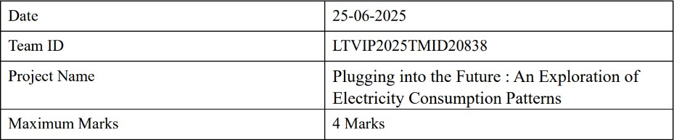

**Problem – Solution Fit Template :**

The Problem–Solution Fit means identifying a key issue faced by electricity consumers and decision-makers specifically the **lack of clear, understandable insights into electricity consumption patterns** and **delivering a Tableau- based interactive dashboard** that solves this problem effectively through visual analytics. This approach helps energy users, analysts, and policy

developers uncover patterns, improve efficiency, and make smarter energy decisions.

**Purpose :**

* Solve **electricity consumption complexities** in a way that suits both technical and

non-technical users.

* Speed up energy insight adoption by leveraging **familiar, visual dashboards via**

**Tableau.**

* Sharpen public awareness and policy direction with **data-backed visuals and storytelling.**
* Increase touch-points with users by solving **frequent energy mismanagement, peak load confusion, and cost concerns.**

**Problem Solution Fit:**



